Contest | Crime Scene Investigation
Chair Contact | Jennifer Choate  jchoate@vacte.com
Skill Performance | The competition will include activities that simulate situations encountered by criminal investigation professionals. See Appendix A for a list of examples.
Team/Ind | Team
Limits | Two
Date/Location/Start Time | February 23,2023  Start Time: 8:00 A.M.  Yavapai College CTEC  Prescott, Arizona
Attire | Class D: Competition Specific — Blue Attire • Official SkillsUSA light blue work shirt • Navy pants Note: Must be work style pants (e.g., Dickie’s) or BDU/tactical style (e.g. 5.11). Accompanied by black or brown belt. • Black, brown, or tan leather work safety shoes (Protective toe cap is not required. Shoes must be professional/police or tactical style boots. No tennis/running style shoes.) Note: Safety glasses must have side shields or goggles. (Prescription glasses may be used only if they are equipped with side shields. If not, they must be covered with goggles.) These regulations refer to clothing items that are pictured and described at www.skillsusastore.org. If you have questions about clothing or other logo items, call 1-888-501-2183. N
Resume | Competitors must create a one-page resume to submit onsite. Failure to submit a resume will result in a 10-point penalty. b. All competitors must create a one-page resume.

Supplied by the technical committee:

1. Crime scene: All necessary materials for the competition not specified elsewhere.

Supplied by Contestant
1.Supplied by the competitors: a. Crime scene kit containing materials necessary to conduct a crime scene investigation. At a minimum:
a) Digital Camera (not a cell phone) with removable media card
b) PPE to include safety glasses, mask/face shield, shoe covers, and gloves (Tyvek optional)
c) Latent print examination kit/fingerprint kit with cards and tape
d) Measuring device (laser measuring device or tape measure)
e) Scale (preferably an ‘L’ shaped scale)
f) Sterile swabs and swab boxes
g) Water in dispenser bottle/dropper (should be distilled, but due to travel restrictions can be tap)
h) Evidence placards/markers/cones
i) Evidence bags; paper and plastic, various sizes
j) Tamper proof evidence tape
k) Sharpie
l) Sketching kit
m) Tweezers
n) small pocket notebook for field notes
o) Pens and #2 pencils
p) Flashlight

PROHIBITED DEVICES Cell phones or other electronic devices not approved by a competition’s national technical committee are NOT allowed in the competition area. Please follow the guidelines in each technical standard for approved exceptions. Technical committee members may also approve exceptions onsite during the SkillsUSA Championships if deemed appropriate. Penalties for Prohibited Devices If a competitor’s electronic device makes noise or if the competitor is seen using it at any time during the competition, an official report will be documented for review by the SkillsUSA Championships director. If confirmed that the competitor used the device in a manner which compromised the integrity of the competition, the competitor’s scores may be canceled.

Scope of the competition

The competition is defined by industry standards as identified by the SkillsUSA technical committee. The following is a list of materials used in the formation of the competition:
• FBI Handbook of Forensic Services (2019): https://www.fbi.gov/file-repository/handbook-of-forensic-services-pdf.pdf/view
• NIST Crime Scene Investigation — A Guide for Law Enforcement (2013): https://www.nist.gov/system/files/documents/forensics/Crime-Scene-Investigation.pdf
• Criminal Investigation by Thomas Brown from Open Educational Resources (2022): https://www.oercommons.org/courses/criminal-investigation KNOWLEDGE PERFORMANCE The competition will include a test assessing knowledge from the Standards and Competencies.
Competitors are also required to take the SkillsUSA professional development test.
SKILLS PERFORMANCE: The competition will include activities that simulate situations encountered by criminal investigation professionals. See Appendix A for a list of examples. COMPETITION GUIDELINES
1. Each competitor must work independently without assistance from instructors, other teams or observers. Contact with competitors must be coordinated through designated event staff only. Any violation of this may disqualify the competitor.
2. Cell phones, iPads/tablets, smart watches, wearable technology, or any other electronic communication device is prohibited in the competition area. See “Prohibited Devices” section above for more information.
3. No one but competitors, judges and event staff are allowed in the competition area at any time. Observation is limited to the area designated by the judges or event staff. Outdoor competition area may only be accessed by judges, competitors, and event staff. Any violation of this may disqualify the competitor. Crime Scene Investigation, 2022-23
4. No one may contact judges in any way and at any time without the expressed permission of the competition coordinator.
KNOWLEDGE PERFORMANCE
Competitors are also required to take the SkillsUSA professional development test. SKILLS PERFORMANCE The competition will include activities that simulate situations encountered by criminal investigation professionals. See Appendix A for a list of examples. COMPETITION GUIDELINES
** The competition will consist of a written test assessing knowledge from the Standards and Competencies if needed as a try breaker. **
1. Each competitor must work independently without assistance from instructors, other teams, or observers. Contact with competitors must be coordinated through designated event staff only. Any violation of this may disqualify the competitor.
2. Cell phones, iPads/tablets, smart watches, wearable technology, or any other electronic communication device is prohibited in the competition area. See “Prohibited Devices” section above for more information.
3. No one but competitors, judges and event staff are allowed in the competition area at any time. Observation is limited to the area designated by the judges or event staff. Outdoor competition area may only be accessed by judges, competitors, and event staff. Any violation of this may disqualify the competitor
COMPETITION GUIDELINES
1. Each competitor must work independently without assistance from instructors, other teams, or observers. Contact with competitors must be coordinated through designated event staff only. Any violation of this may disqualify the competitor.
2. Cell phones, iPads/tablets, smart watches, wearable technology, or any other electronic communication device is prohibited in the competition area. See “Prohibited Devices” section above for more information.
3. No one but competitors, judges and event staff are allowed in the competition area at any time. Observation is limited to the area designated by the judges or event staff. Outdoor competition area may only be accessed by judges, competitors, and event staff. Any violation of this may disqualify the competitor. Crime Scene Investigation, 2022-23.
4. No one may contact judges in any way and at any time without the expressed permission of the competition coordinator.

STANDARDS AND COMPETENCIES
CSI 1.0 — Demonstrate or explain activities prior to conducting a crime scene search
1.1. Obtain information from the responding officer and secure the scene
1.2. Explain laws, processes and protocols securing a scene
1.3. Explain laws and legal issues related to crime scene processing

CSI 2.0 — Explain and demonstrate the use of crime scene photography
2.1. Demonstrate proper crime scene photography
2.2. Document photographs taken at the crime scene

CSI 3.0 — Properly search for, collect, and remove physical evidence from a crime screen
3.1. Explain and demonstrate appropriate search method to use
3.2. Properly identify and mark all evidence
3.3. Explain methods for collecting various types of evidence
3.4. Explain and demonstrate proper preserving and preparing for transport of all evidence

CSI 4.0 — Draw a crime scene sketch using proper measurements, symbols, and labels
4.1. Demonstrate proper use of measurements
4.2. Demonstrate the proper use of symbols and labels
4.3. Complete a sketch including all required elements

CSI 5.0 — Apply proper procedures for developing and collecting latent fingerprints at a crime scene 5.1. Demonstrate the ability to properly lift and transfer a latent fingerprint from a designated item of evidence
5.2. Demonstrate the proper procedure for completing a latent fingerprint card

CSI 6.0 — Release a crime screen properly and legally
6.1. Demonstrate the ability to prepare an evidence log
6.2. Demonstrate the ability to remove all evidence and equipment from crime scene

CSI 7.0 — Work together as a professional team to conduct a crime scene investigation
7.1. Demonstrate professional bearing and demeanor
7.2. Demonstrate the ability to assign team members’ tasks equal to their aptitude
CSI 8.0 — SkillsUSA Framework.
The SkillsUSA Framework is used to pinpoint the Essential Elements found in Personal Skills, Workplace Skills and Technical Skills Grounded in Academics. Students will be expected to display or explain how they used some of these Essential Elements. Please reference the graphic above, as you may be scored on specific elements applied to your project.
For more visit: www.skillsusa.org/about/skillsusa-framework/.

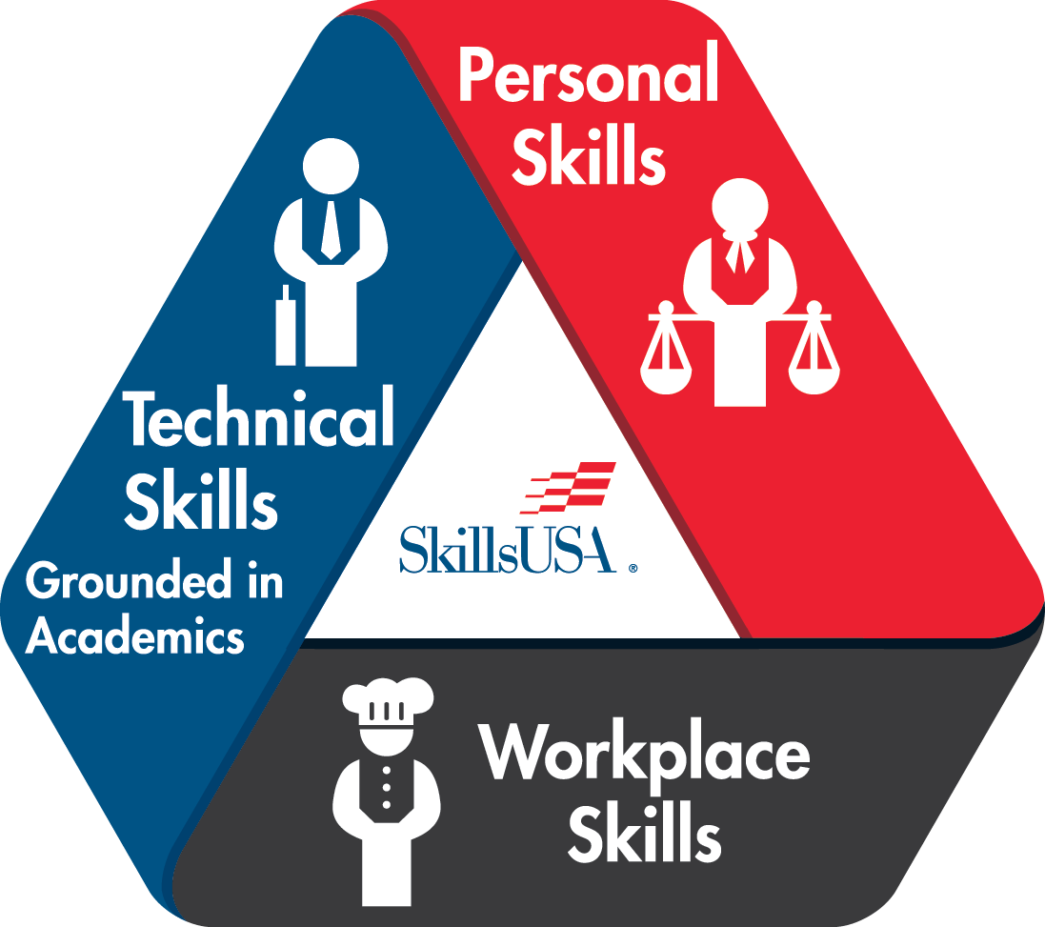

Appendix A The list below is not exhaustive, but represents the range of possible competition skills
• Lifting fingerprints
• Collecting DNA and bodily fluid evidence
• Photographing scene
• Photographic evidence
• Sketching a scene
• Measuring a scene
• Searching for and identifying evidence
• Identify, collect, and process trace evidence
• Interpret blood stains
• Interpret ballistic evidence – casings, directionality, sequencing
• Complete paperwork associated with CSI – including narratives, logs
• Practice safety protocols related to CSI
• Collect evidence
• Verbalize constitutional and legal applications in scenarios
• Interpret DNA evidence
• Classify, interpret and identify fingerprint evidence
• Packaging and preserving various types of evidence
• Presumptive testing
• Interpretation of anthropological evidence

COMMITTEE IDENTIFIED ACADEMIC SKILLS The technical committee has identified that the following academic skills are embedded in this competition.
Math Skills
• Measure angles
• Use the rectangular coordinate method to locate evidence (uses two fixed reference points and right angles to indicate the exact location of evidence in the crime scene)

Science Skills
• Plan and conduct a scientific investigation
• Use the proper method for developing latent fingerprints
• Identify and demonstrate necessary safety precautions for handling and processing DNA evidence

Language Arts Skills
• Provide information in conversations and in group discussions
• Provide information in oral presentations
• Demonstrate use of such verbal communication skills as word choice, pitch, feeling, tone, and voice
• Demonstrate use of such nonverbal communication skills as eye contact, posture and gestures using interviewing techniques to gain information
• Organize and synthesize information for use in written and oral presentations
• Demonstrate informational writing
• Edit writing for correct grammar, capitalization, punctuation, spelling, sentence structure and paragraphing

Language Arts Standards
• Students adjust their use of spoken, written and visual language (e.g., conventions, style, vocabulary) to communicate effectively with a variety of audiences and for different purposes.
• Students conduct research on issues and interests by generating ideas and questions and by posing problems. They gather, evaluate, and synthesize data from a variety of sources (e.g., print and nonprint texts, artifacts, people) to communicate their discoveries in ways that suit their purpose and audience.
• Students use spoken, written and visual language to accomplish their own purposes (e.g., for learning, enjoyment, persuasion, and the exchange of information).

Source: IRA/NCTE Standards for the English Language Arts. To view the standards, visit: www.ncte.org/standards

